JECRC
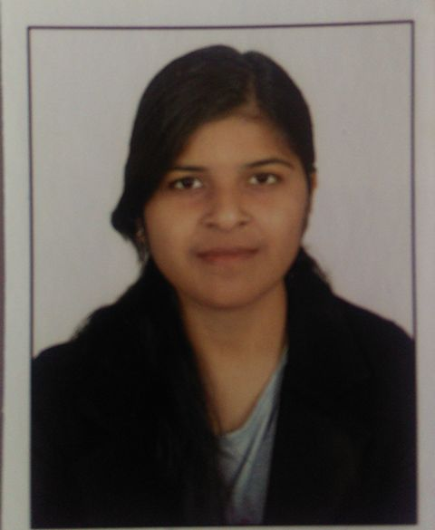 Affix and Attest
passport
size photograph
JAIPUR

INDIVIDUAL Lab Instructor DATA SHEET
Name of the Lab Instructor | : | Vaishali yadav
Present Designation | : | Lab Instructor
Email Id: vaishaliyadav.yadav095@gmail.com
Contact Details: +917737185459

I. Particulars of Educational Qualification: (only completed)

Category | Name of the Degree | Specialization | Year of Passing | Name of the College | Name of the University
Diploma | Diploma | electronics | 2012 | GRCK | BTER

II. Academic Experience : 5 Year

III. Industrial Experience :

IV. Awards/Achievements :

VI. Research/Specialization :

VII. Course Taught :

